k
Express with Mongoose

Updating it sometimes a lot of work because you’ve got o render an edit form, you’’ve got to populate it with the data that’s already, you know the thing that you’re updating the current values, then you need to route to submit it to and then do the actual updating logic.
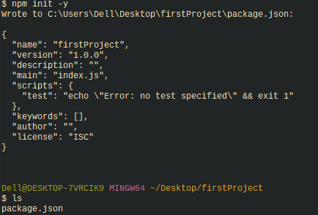

>ls
>npm init -y <!-- It will take the folder name
>npm I express ejs mongoose
>touch index.js; mkdir views
>nodemon index.js
Note: On browser ------→http://localhost:3000/dog
Tip: its easiest to take the basic code required and shove it in index.js and eventually this file would be very small, we would remove all the routes and just have the basic logic to start a server.
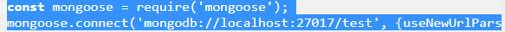

Tip: we gonna make a seperate folder for models, and then we can put all of our models in there, since you have many models, especially because often they’ll reference one another and you have different files. You might have a root file for each model. You might have different just completely seperate file that also required specific models. So it’s a lot easier if we isolate them.

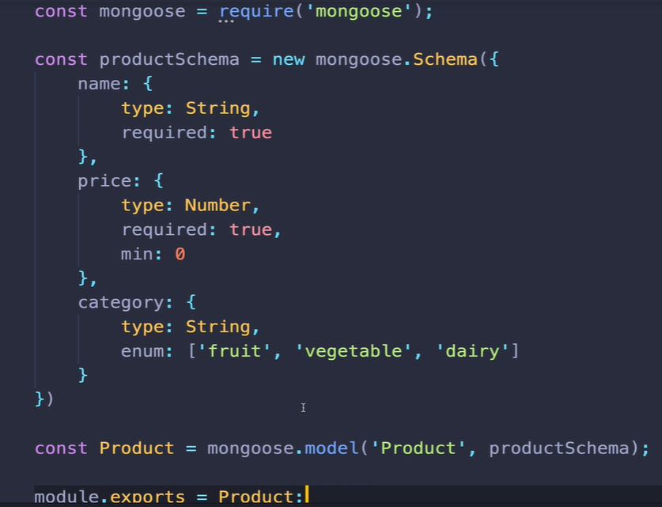

findById()
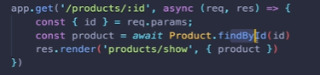

Above, we pass the data from db to template, but if we making or if we making json api we can render the model data as json.

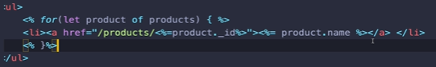

Creating products
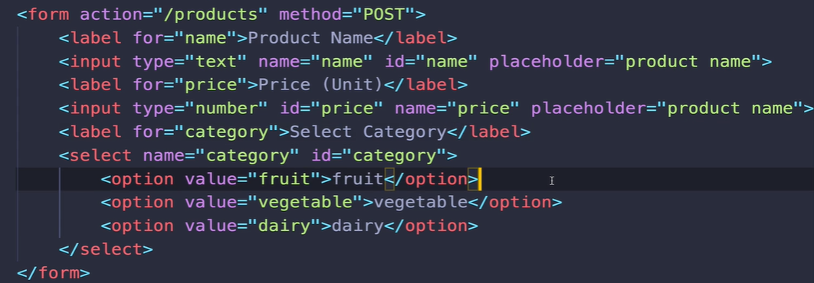

Then
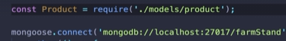

Then
seed data.
>touch seeds.js
Note: place the entire mongoose code i.e require+conn.
This is the file I am gonna run when I want data in my db. Its a very common practice to seed ur db seperately from the web app.Also I wanna isolate this from actual index of our application.
-Also you need to require the model for who this seed is .
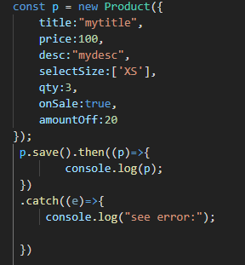

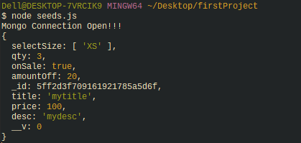

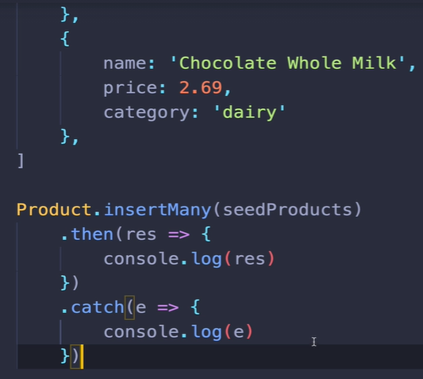

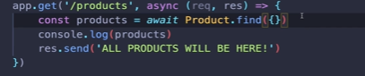

now we have to render, instead of console.
>touch views/products/index.ejs
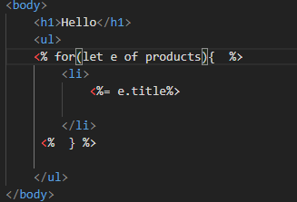

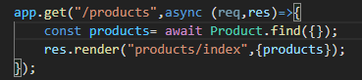

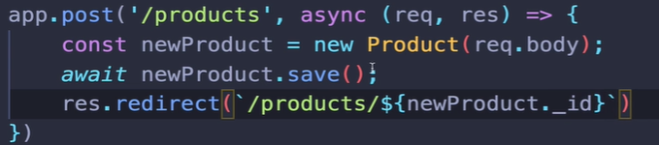

Updating products
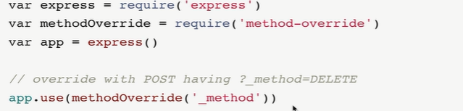
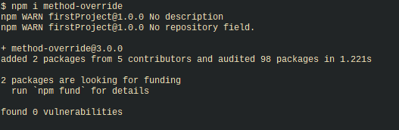

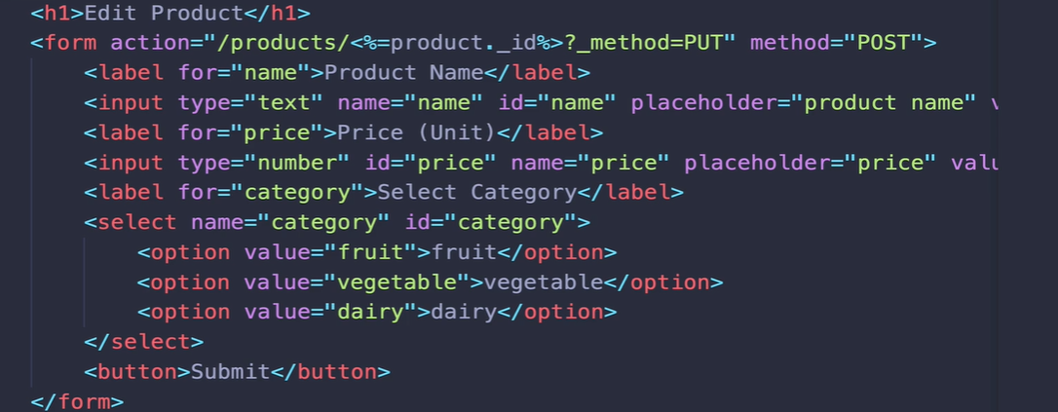
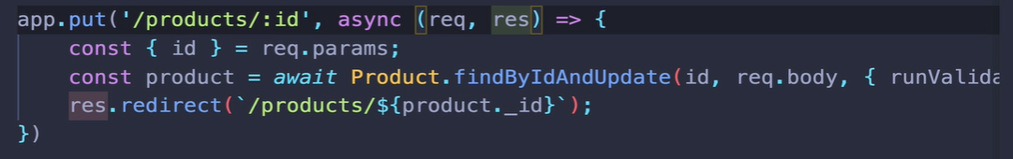

Tangent on category selector
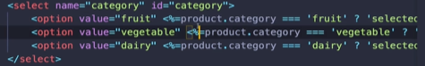

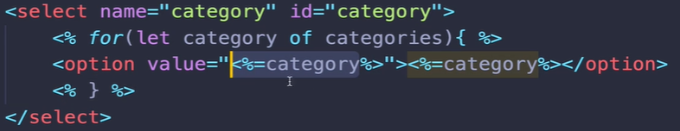
Delete products
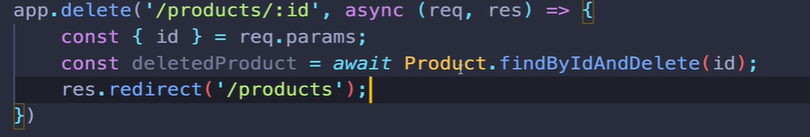

Bonus: filtering by category

What if I wanna view products by category, I am thinking making of the fruit text a button so when I click on it will list all fruits or where categoryis fruit.
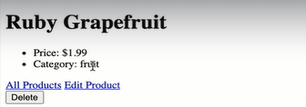

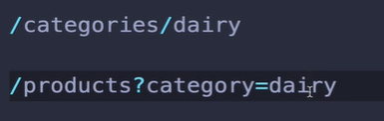
How will I structure the url?

Generally, query strings are used for filtering or searching basically a subset of info. But where as for (1)
1

2
we are making categories potentially a resource, elevating on its own path here.
It might be better for us to use if the category have some features or there
are bunch of categories and I want to be able to view all categories or if I want to be able to create new categories on the fly throught the application.
Honestly, though you cant really go wrong as long as you are consistent in the application, how you follow or layout your routes
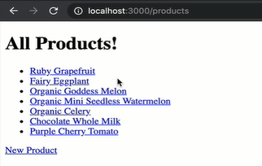

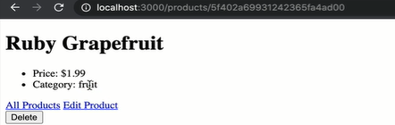

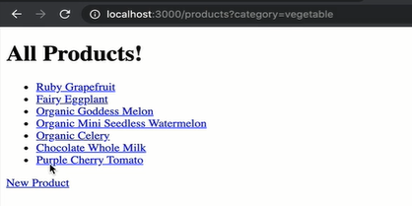

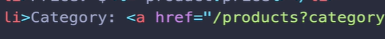

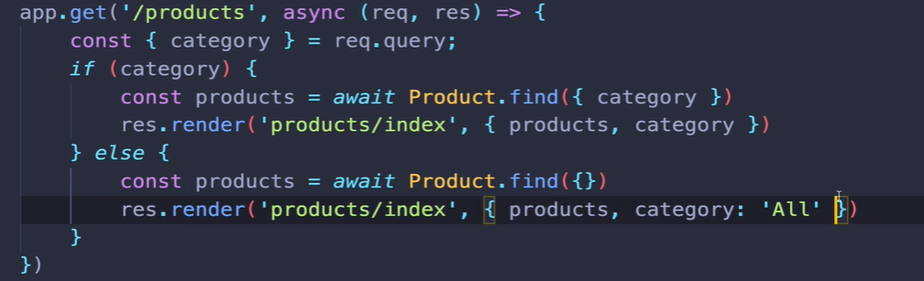
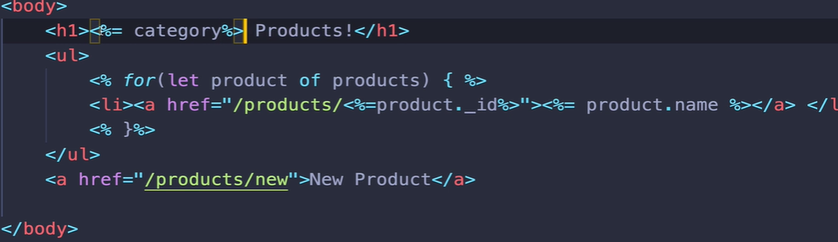
if I am on a category, I want a link to go to “all products”
